LAB 1:
1. Create a Simple Website Titled Introduction to HTML. Add a large heading using <h1>tag titled HTML
Basics. Use <h2> tags for section heading. Create 2 section headings: Use of <p> tag and User of <pre>
tag. Under these headings show the use case of <p> and <pre> tags.
Source Code:

<!DOCTYPE html>
<html lang="en">
<head>
<meta charset="UTF-8">
<meta name="viewport" content="width=device-width, initial-scale=1.0">
<title>Report 1</title>
</head>
<body>
<h1>HTML Basics</h1>
<h2>Use of &lt;p&gt; Tag</h2>
<p>The &lt;p&gt; tag is used to define paragraphs in HTML. It is a block-level element that adds space before and after the text, making it easier to read. Here is an example of a paragraph:</p>
<p>This is an example of a paragraph created using the &lt;p&gt; tag. Notice how the browser automatically adds space around this block of text.</p>
<h2>Use of &lt;pre&gt; Tag</h2>
<p>The &lt;pre&gt; tag is used to define preformatted text. Text within this tag is displayed in a fixed-width font, and white spaces, line breaks, and formatting are preserved. Here is an example:</p>
<pre>
This is an example of preformatted text.
Line breaks and spaces are preserved.
Useful for displaying code snippets or text with specific formatting.
</pre>
</body>
</html>

Output:
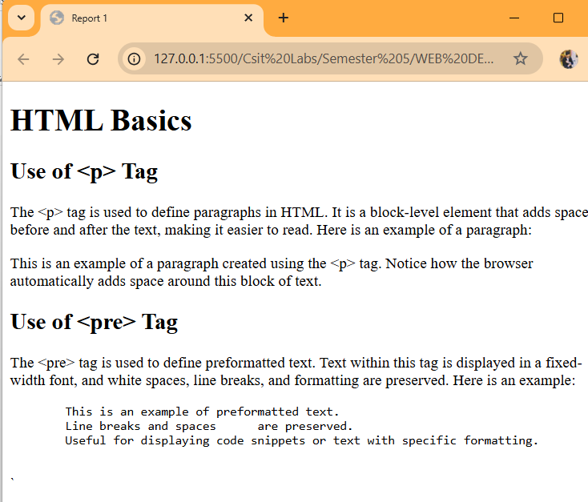

2. Create a webpage with an HTML table showcasing different projects chosen by students. Student
Columns:
a. S.N
b. Project Name
c. Student Name
d. Exam Roll Number
e. Remarks
Use thead, tbody and tfoot. Use border attribute to have 2 table borders. Use rowspan and colspan in
the necessary areas. The table should have at least 4 projects involving 7 students

Source Code:
<!DOCTYPE html>
<html lang="en">
<head>
<meta charset="UTF-8">
<meta name="viewport" content="width=device-width, initial-scale=1.0">
<title>Report 1</title>
</head>
<body>
<h1>Student Projects Table</h1>
<table border="2">
<thead>
<tr>
<th>S.N</th>
<th>Project Name</th>
<th>Student Name</th>
<th>Exam Roll Number</th>
<th>Remarks</th>
</tr>
</thead>
<tbody>
<tr>
<td rowspan="2">1</td>
<td rowspan="2">Science</td>
<td>Priyanshu Shrestha</td>
<td>201</td>
<td rowspan="2">Excellent</td>
</tr>
<tr>
<td>Shuvam Shakya</td>
<td>202</td>
</tr>
<tr>
<td>2</td>
<td>Mathematics</td>
<td>Raka Maharajan</td>
<td>203</td>
<td>Good</td>
</tr>
<tr>
<td>3</td>
<td rowspan="2">Social Studies</td>
<td>Md Mojibul</td>
<td>204</td>
<td>Very Good</td>
</tr>
<tr>
<td>4</td>
<td>Babin Rana</td>
<td>205</td>
<td>Good</td>
</tr>
<tr>
<td>5</td>
<td>Nepali</td>
<td>Bipin Pandey</td>
<td>206</td>
<td>Outstanding</td>
</tr>
</tbody>
<tfoot>
<tr>
<td colspan="5">This table showcases projects chosen by students with their details.</td>
</tr>
</tfoot>
</table>
</body>
</html>

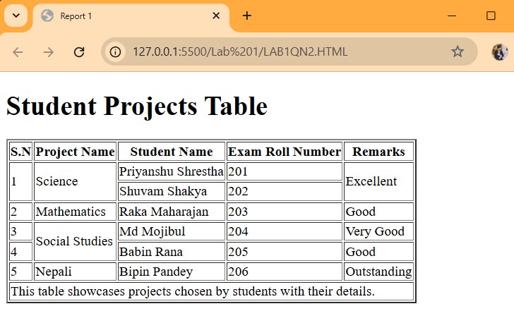
Output:

3. Create a search bar using get method.
Source Code:
<!DOCTYPE html>
<html lang="en">
<head>
<meta charset="UTF-8">
<meta name="viewport" content="width=device-width, initial-scale=1.0">
<title>Search Bar</title>
</head>
<body>

<h2>Search Bar</h2>
<form method="post" action="/search">
<label for="query">Search:</label>
<input type="text" id="query" name="query" placeholder="Enter your search term">
<button type="submit">Search</button>
</form>

</body>
</html>

Output:
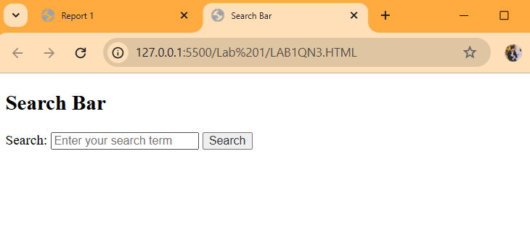

4. Create a User Registration form with following details.
a. Name
b. Email
c. Password
d. Gender (Radio Button)
e. Hobbies (Checkbox)
f. Submit button

Source Code:
<!DOCTYPE html>
<html lang="en">
<head>
<meta charset="UTF-8">
<meta name="viewport" content="width=device-width, initial-scale=1.0">
<title>Introduction to HTML</title>
</head>
<body>

<h2>User Registration Form</h2>
<form method="post" action="/register">
<label for="name">Name:</label>
<input type="text" id="name" name="name" placeholder="Enter your name" required><br><br>

<label for="email">Email:</label>
<input type="email" id="email" name="email" placeholder="Enter your email" required><br><br>

<label for="password">Password:</label>
<input type="password" id="password" name="password" placeholder="Enter your password" required><br><br>

<label>Gender:</label>
<input type="radio" id="male" name="gender" value="male" required>
<label for="male">Male</label>
<input type="radio" id="female" name="gender" value="female" required>
<label for="female">Female</label><br><br>
<label>Hobbies:</label>
<input type="checkbox" id="reading" name="hobbies" value="reading">
<label for="reading">Reading</label>
<input type="checkbox" id="sports" name="hobbies" value="sports">
<label for="sports">Sports</label>
<input type="checkbox" id="music" name="hobbies" value="music">
<label for="music">Music</label><br><br>

<button type="submit">Submit</button>
</form>
</body>
</html>

Output:
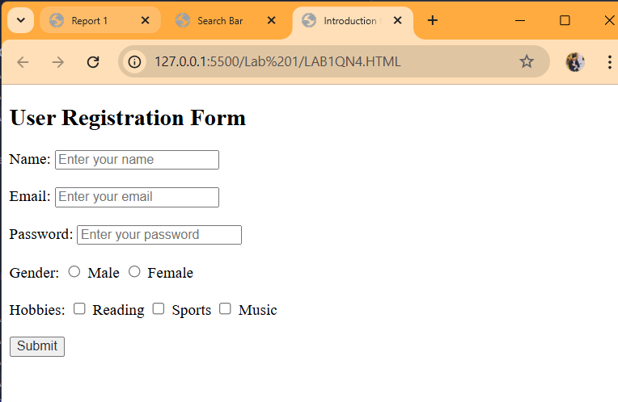

5. Create a webpage titled Top 3s trekking destinations in Nepal. Add a heading using <h1> tag. Insert
images of 3 popular destinations in the webpage. Use caption tag to label these images. Make use of alt
for each images of equal width 300px.

Source Code:
<!DOCTYPE html>
<html lang="en">
<head>
<meta charset="UTF-8">
<meta name="viewport" content="width=device-width, initial-scale=1.0">
<title>Top 3 Trekking Destinations in Nepal</title>
</head>
<body>
<h1>Top 3 Trekking Destinations in Nepal</h1>

<figure>
<img src="everest.jpg" alt="Everest Base Camp" width="300">
<figcaption>Everest Base Camp</figcaption>
</figure>
<figure>
<img src="annapurna.jpg" alt="Annapurna Circuit" width="300">
<figcaption>Annapurna Circuit</figcaption>
</figure>

<figure>
<img src="Langtang.webp" alt="Langtang Valley Trek" width="300">
<figcaption>Langtang Valley Trek</figcaption>
</figure>
</body>
</html>

Output:


LAB 2:
1. Create a website titled ACHS Blogs. The website tab must have achs logo as well. The website. must have a head section, nav bar with Home, About and Contact along with ACHS logo. There must be a section in main for article on Sports Week. You may use auto generated paragraphs for the article. Your website must have an aside section for additional contents. Include links for Examination, Music Fest and Hackathon. Finally use footer tag for copyright symbol and year with name of college
2. In the previous website, on clicking home the user must be redirected to home.htm which then redirects the user to ACHS website https://achs.edu.np/
Source Code:
<!DOCTYPE html>
<html lang="en">
<head>
<meta charset="UTF-8">
<meta name="viewport" content="width=device-width, initial-scale=1.0">
<title>Achs Blogs</title>
</head>
<body>
<nav>
<img src="achs.ico" alt="Image of ACHS logo">
<a href="https://achsnepal.edu.np/"target="_blank">Home</a>
<a href="about">About</a>
<a href="contact">Contact</a>
</nav>
<p>
<h2>Sports Week</h2>
<p>
Sports Week is a much-anticipated event in schools, colleges, and communities, offering a vibrant mix of athletic competitions,
team-building activities, and celebrations of physical fitness.
This weeklong festival brings together participants of all ages to showcase their talents, foster camaraderie, and embrace the spirit of healthy competition.
The essence of Sports Week lies in promoting both physical and mental well-being. From track and field events to team sports like basketball and soccer,
participants engage in a variety of activities designed to challenge their skills and endurance. These events not
only encourage active lifestyles but also highlight the importance of perseverance, discipline, and teamwork.
</p>
</section>
<section>
<h3>Additional contents</h3>
<p>
<li><a href="Examinaion">Examinaion</a></li>
<li><a href="Music fest">Music Fest</a></li>
<li><a href="Hackathon">Hackathon</a></li>
</p>
</section>
<footer>
<p>
&copy;2025 Asian College Of Higher Studies
</p>
</footer

</section>
</body>
</body>
</html>

Output:
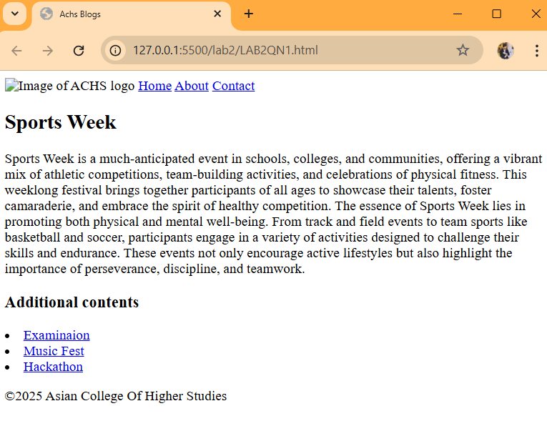
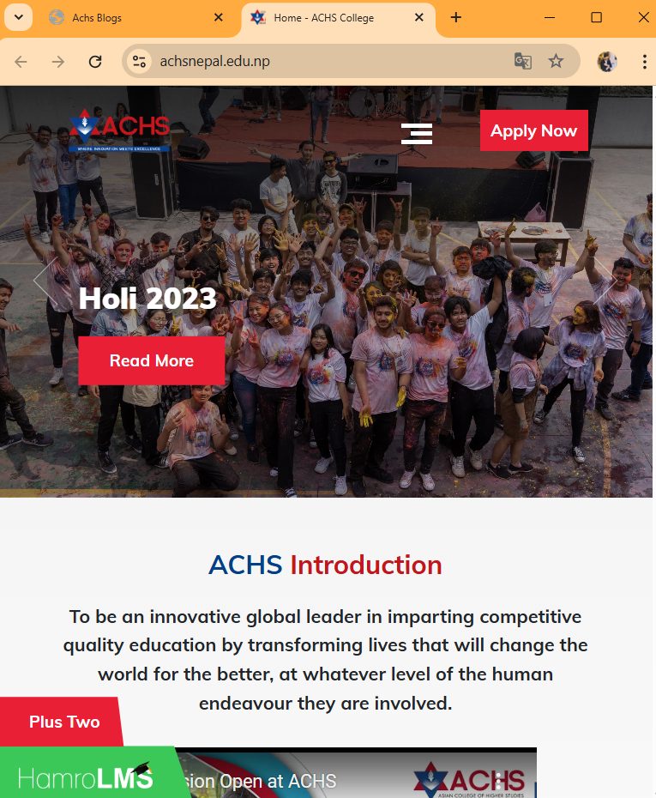

LAB 3:

- Create the following layout for your ecommerce website using external CSS.
Source Code:
HTML Code:
<!DOCTYPE html>
<html lang="en">
<head>
<meta charset="UTF-8">
<meta name="viewport" content="width=device-width, initial-scale=1.0">
<title>Ecommerce Layout</title>
<link rel="stylesheet" href="Q1.css">
</head>
<body>
<div class="container">
<div class="header">
Navigation Menus Here
</div>
<div class="left-advertisement">
Place your advertisement here
</div>
<div class="products">
<div class="product">Products Here</div>
<div class="product">Products Here</div>
<div class="product">Products Here</div>
<div class="product">Products Here</div>
<div class="product">Products Here</div>
<div class="product">Products Here</div>
<div class="product">Products Here</div>
<div class="product">Products Here</div>
<div class="product">Products Here</div>
</div>
<div class="right-advertisement">
Place your advertisement here
</div>
</div>
</body>
</html>

CSS Code:
body, html {
margin: 0;
padding: 0;
font-family: Arial, sans-serif;
box-sizing: border-box;
}

.container {
display: grid;
grid-template-areas:
"header header header"
"left-advertisement products right-advertisement";
grid-template-columns: 1fr 3fr 1fr;
grid-template-rows: auto 1fr;
height: 100vh;
gap: 15px; /* Increased gap for better spacing */
padding: 20px; /* Added padding to the container */
}

.header {
grid-area: header;
background-color: #f8f8f8;
border: 1px solid #ccc;
text-align: center;
padding: 15px; /* Adjusted padding */
margin-bottom: 10px; /* Added margin for separation */
font-size: 18px;
font-weight: bold;
}

.left-advertisement,
.right-advertisement {
background-color: #a0c4a0;
padding: 15px; /* Adjusted padding */
text-align: center;
font-size: 14px;
color: #000000;
border: 1px solid #ccc;
}

.left-advertisement {
grid-area: left-advertisement;
}

.right-advertisement {
grid-area: right-advertisement;
}

.products {
grid-area: products;
display: grid;
grid-template-columns: repeat(3, 1fr);
gap: 15px; /* Adjusted gap for better spacing */
padding: 15px; /* Added padding */
}

.product {
background-color: #88aaff;
text-align: center;
padding: 20px; /* Adjusted padding for uniformity */
color: rgb(0, 0, 0);
border: 1px solid #ccc;
font-size: 14px;
margin: 5px; /* Added margin for separation */
}

Output:
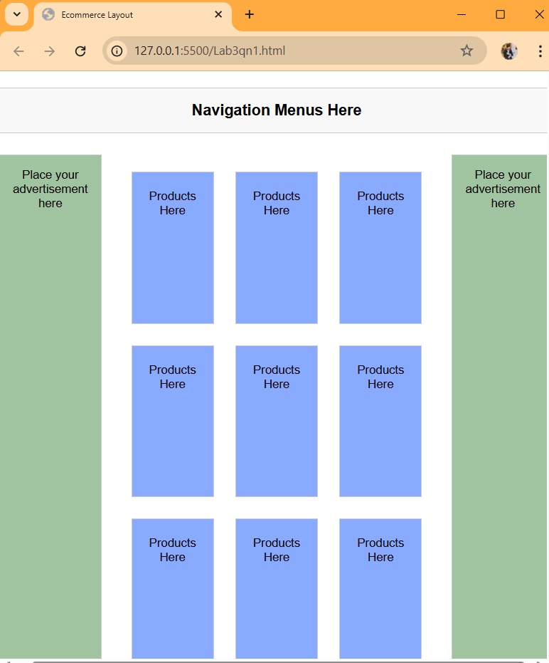

- Create a Table with project details using only divs. You may take reference from the practical session of Lab 1 table. Make use of internal CSS.
Source Code:
HTML Code:
<!DOCTYPE html>
<html lang="en">
<head>
<meta charset="UTF-8">
<meta name="viewport" content="width=device-width, initial-scale=1.0">
<title>Document</title>
<link rel="stylesheet" href="Q2.css">
</head>
<body>

<div class="table-container">
<div class="row header">
<div class="cell">Project Name</div>
<div class="cell">Start Date</div>
<div class="cell">End Date</div>
<div class="cell">Status</div>
</div>
<div class="row">
<div class="cell">Project A</div>
<div class="cell">01-Jan-2023</div>
<div class="cell">30-Jun-2023</div>
<div class="cell">Completed</div>
</div>
<div class="row">
<div class="cell">Project B</div>
<div class="cell">15-Feb-2023</div>
<div class="cell">15-Aug-2023</div>
<div class="cell">In Progress</div>
</div>
<div class="row">
<div class="cell">Project C</div>
<div class="cell">01-Mar-2023</div>
<div class="cell">30-Sep-2023</div>
<div class="cell">Pending</div>
</div>
</div>

</body>
</html>

CSS Code:
* {
margin: 0;
padding: 0;
box-sizing: border-box;
}

body {
font-family: Arial, sans-serif;
margin: 20px;
background-color: #f9f9f9;
color: black;
}

.table-container {
display: flex;
flex-direction: column;
border: 1px solid #ccc;
border-radius: 5px;
overflow: hidden;
max-width: 800px;
margin: 0 auto;
box-shadow: 0 2px 5px rgba(0, 0, 0, 0.1);

}

.row {
display: flex;
}

.cell {
flex: 1;
padding: 10px;
border-bottom: 1px solid #ccc;
text-align: center;
}

/* Header styles */
.row.header {
background-color: #4CAF50;
color: white;
font-weight: bold;
}

.row:last-child .cell {
border-bottom: none;
}

/* Column span (colspan) */
.cell.colspan-2 {
flex: 2; /* Span across 2 columns */
}

/* Row span (rowspan) */
.rowspan-2 {
display: flex;
flex-direction: column;
justify-content: center;
align-items: center;
flex-grow: 2; /* Take up space for 2 rows */
border-right: 1px solid #ccc; /* Add a border to separate columns */
}

Output:
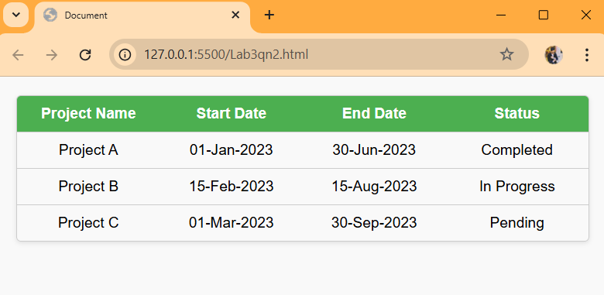

- Use external CSS to design the form you created in the 1st Practical Session. The final form should resemble one given below. You may choose the colors and fonts as per your wish.

Source Code:
HTML Code:
<!DOCTYPE html>
<html lang="en">
<head>
<meta charset="UTF-8">
<meta name="viewport" content="width=device-width, initial-scale=1.0">
<title>Registration Form</title>
<link rel="stylesheet" href="Q3.css">
</head>
<body>
<div class="form-container">
<form>
<h2>Full Name:</h2>
<input type="text" placeholder="Enter your Name" required>

<h2>Email ID:</h2>
<input type="email" placeholder="Enter your Email" required>

<h2>Password:</h2>
<input type="password" placeholder="Enter your Password" required>

<h2>Gender:</h2>
<div class="gender">
<label><input type="radio" name="gender" value="Female"> Female</label>
<label><input type="radio" name="gender" value="Male"> Male</label>
</div>

<h2>Click on your interests:</h2>
<div class="interests">
<label><input type="checkbox" name="interest" value="Coding"> Coding</label>
<label><input type="checkbox" name="interest" value="Singing"> Singing</label>
<label><input type="checkbox" name="interest" value="Football"> Football</label>
<label><input type="checkbox" name="interest" value="Dancing"> Dancing</label>
<label><input type="checkbox" name="interest" value="Basketball"> Basketball</label>
</div>

<button type="submit">Register</button>
</form>
</div>
</body>
</html>

CSS Code:
body {
font-family: Arial, sans-serif;
background-color: #a9c4c4;
display: flex;
justify-content: center;
align-items: center;
height: 100vh;
margin: 0;
}

.form-container {
background-color: #6d7b6d;
border-radius: 10px;
padding: 20px;
width: 350px;
box-shadow: 0px 4px 6px rgba(0, 0, 0, 0.1);
}
form {
display: flex;
flex-direction: column;
gap: 15px;
}
h2 {
font-size: 16px;
color: white;
margin-bottom: 5px;
}
input[type="text"],
input[type="email"],
input[type="password"] {
width: 100%;
padding: 8px;
border: none;
border-radius: 5px;
box-shadow: 0px 2px 4px rgba(0, 0, 0, 0.1);
margin-bottom: 10px;
}
.gender, .interests {
display: flex;
justify-content: space-between;
background-color: #a9c4c4;
padding: 10px;
border-radius: 5px;
}

label {
font-size: 14px;
color: #333;
}
button {
background-color: #32534c;
color: white;
border: none;
padding: 10px;
border-radius: 5px;
cursor: pointer;
font-size: 16px;
}
button:hover {
background-color: #264239;
}
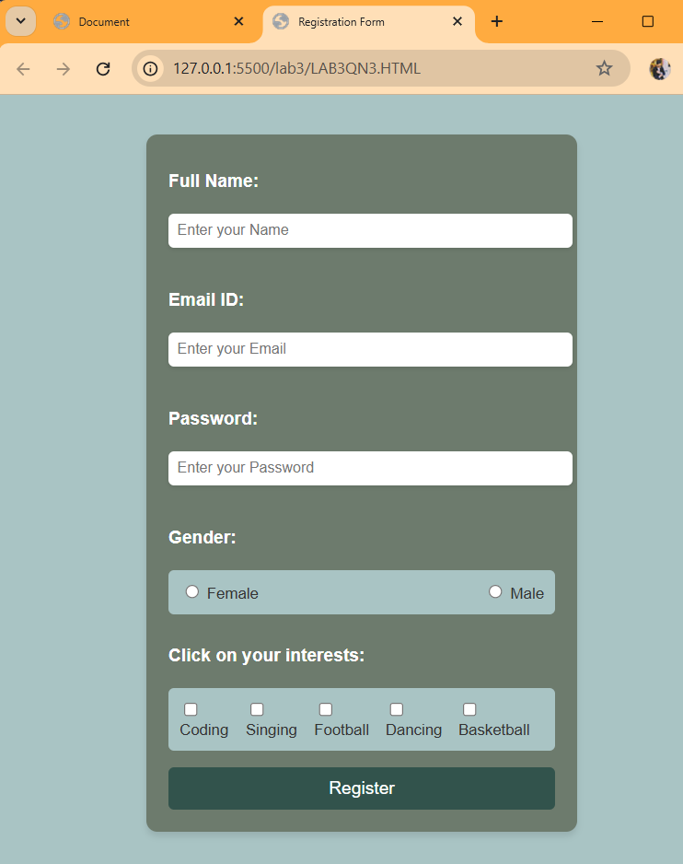
Output:

LAB 4:

1. Write a JavaScript Program depicting the use of arrow function. Use this program to generate a Fibonacci series.
Source Code:
<!DOCTYPE html>
<html lang="en">
<head>
<meta charset="UTF-8" />
<meta name="viewport" content="width=device-width, initial-scale=1.0" />
<title>23081002 Qn1</title>
</head>
<body>
<label for="">Enter number: </label>
<input id="input" type="number" />
<button id="btn">Answer</button>
<br />
<br />
<p id="para">Answer comes here:</p>

<script>
const myPara = document.getElementById("para");
const button = document.getElementById("btn");

function fibonacciSequence(n) {
let sequence = [];
let a = 0,
b = 1;
for (let i = 0; i < n; i++) {
sequence.push(a);
let temp = a + b;
a = b;
b = temp;
}
return sequence;
}

const testFunc = () => {
const inpString = document.getElementById("input");
const inpVal = parseInt(inpString.value, 10);
if (isNaN(inpVal) || inpVal < 1) {
myPara.innerText = "Please enter a valid positive number.";
return;
}

myPara.innerText = `Fibonacci sequence up to ${inpVal}: ${fibonacciSequence(
inpVal
).join(", ")}`;
};
button.addEventListener("click", testFunc);
</script>
</body>
</html>

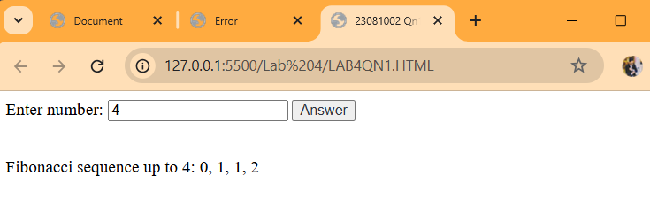
Output:

2. Calculate the factorial of a number by using recursive function. Prompt the number from user input.

Source Code:
<!DOCTYPE html>
<html lang="en">
<head>
<meta charset="UTF-8" />
<meta name="viewport" content="width=device-width, initial-scale=1.0" />
<title>23081002 Factorial Calculator</title>
</head>
<body>
<h1>Factorial Calculator</h1>
<label for="number">Enter a number:</label>
<input type="number" id="number" name="number" />
<button onclick="calculateFactorial()">Calculate</button>
<p id="result"></p>

<script>
function factorial(n) {
if (n === 0 || n === 1) {
return 1;
} else {
return n * factorial(n - 1);
}
}

function calculateFactorial() {
const number = parseInt(
document.getElementById("number").value
);
if (isNaN(number) || number < 0) {
document.getElementById("result").innerText =
"Please enter a valid non-negative integer.";
console.log(
"Invalid input: Please enter a non-negative integer."
);
} else {
const result = factorial(number);
document.getElementById(
"result"
).innerText = `Factorial of ${number} is ${result}.`;
console.log(`Factorial of ${number} is ${result}.`);
}
}
</script>
</body>
</html>

Output:

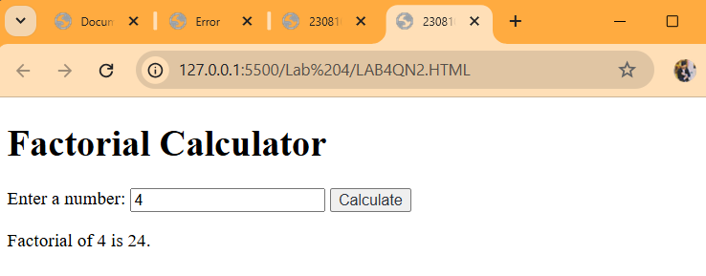

3. Design the form for registration of a new user using HTML. The form must contain fields
for Full Name of User, Email Address and Password. Use JavaScript to validate the
following:
a. The Name of the user must be at least 3 characters long and should not contain
any numbers.
b. Email Address validation
c. Password must be at least 8 characters long and must contain at least 1 number, 1 upper case character, 1 lower case character and 1 special character [@,!,$,#,etc.]

Source Code:
<!DOCTYPE html>
<html lang="en">
<head>
<meta charset="UTF-8" />
<meta name="viewport" content="width=device-width, initial-scale=1.0" />
<title>23081002 Registration Form</title>
<style>
body {
font-family: "Segoe UI", Tahoma, Geneva, Verdana, sans-serif;
display: flex;
justify-content: center;
align-items: center;
min-height: 100vh;
background-color: #f4f4f4;
margin: 0;
}
.form-container {
text-align: center;
width: 350px;
background-color: #fff;
padding: 20px;
border-radius: 8px;
box-shadow: 0 0 10px rgba(0, 0, 0, 0.1);
}
h1 {
color: #333;
margin-bottom: 15px;
}
label {
display: block;
margin-top: 10px;
text-align: left;
color: #555;
}
input {
width: 100%;
padding: 10px;
margin-top: 5px;
border: 1px solid #ddd;
border-radius: 5px;
font-size: 14px;
box-sizing: border-box;
}
button {
width: 100%;
padding: 12px;
background-color: #18a2ac;
color: white;
border: none;
border-radius: 5px;
cursor: pointer;
font-size: 16px;
margin-top: 15px;
transition: background-color 0.3s ease;
}
</style>
</head>
<body>
<div class="form-container">
<h1>Register</h1>
<form id="registrationForm">
<label for="name">Full Name:</label>
<input type="text" id="name" name="name" required />
<label for="email">Email Address:</label>
<input type="email" id="email" name="email" required />
<label for="password">Password:</label>
<input type="password" id="password" name="password" required />
<button type="submit">Register</button>
</form>
</div>
<script>
document
.getElementById("registrationForm")
.addEventListener("submit", function (event) {
const name = document.getElementById("name");
const email = document.getElementById("email");
const password = document.getElementById("password");
let isValid = true;
// Validate Name
if (!/^[A-Za-z ]{3,}$/.test(name.value)) {
name.setCustomValidity(
"Name must be at least 3 characters long and should not contain numbers."
);
console.log(
"Error: Name must be at least 3 characters long and should not contain numbers."
);
isValid = false;
} else {
name.setCustomValidity("");
console.log("Valid Name:", name.value);
}
// Validate Email
if (!/^[^\s@]+@[^\s@]+\.[^\s@]+$/.test(email.value)) {
email.setCustomValidity(
"Please enter a valid email address."
);
console.log("Error: Invalid Email Address.");
isValid = false;
} else {
email.setCustomValidity("");
console.log("Valid Email:", email.value);
}
// Validate Password
if (
!/^(?=.*[a-z])(?=.*[A-Z])(?=.*\d)(?=.*[@!$#])[A-Za-z\d@!$#]{8,}$/.test(
password.value
)
) {
password.setCustomValidity(
"Password must be at least 8 characters long, with at least 1 number, 1 uppercase letter, 1 lowercase letter, and 1 special character (@,!,$,#, etc.)."
);
console.log("Error: Invalid Password.");
isValid = false;
} else {
password.setCustomValidity("");
console.log("Valid Password:", password.value);
}
if (!isValid) {
event.preventDefault();
name.reportValidity();
email.reportValidity();
password.reportValidity();
} else {
console.log("Form submitted successfully!");
}
});
</script>
</body>
</html>
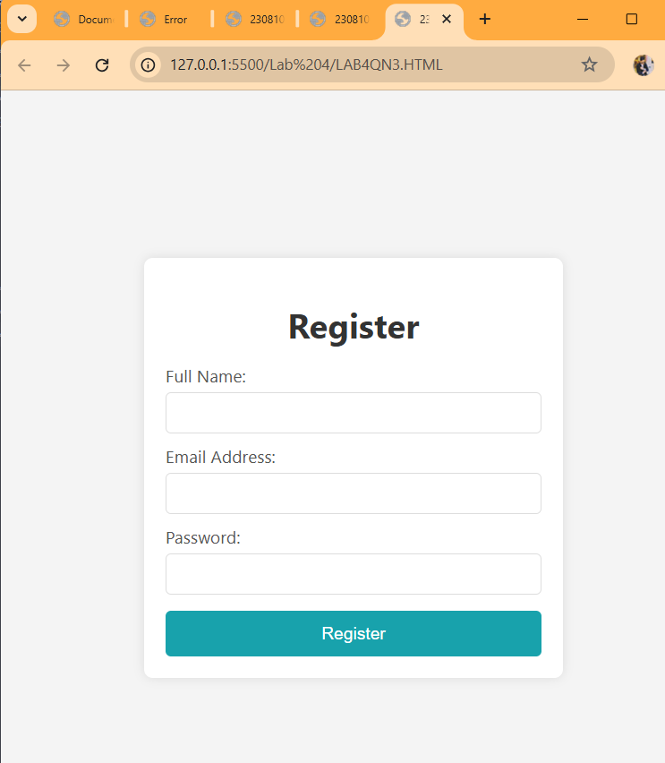
Output:

4. Write a JavaScript Program to toggle the back ground color from dark to light and vice
versa. However the mode should persist on reloading as well.

Source Code:
<!DOCTYPE html>
<html lang="en">
<head>
<meta charset="UTF-8" />
<meta name="viewport" content="width=device-width, initial-scale=1.0" />
<title>23081002 Toggle Background Color</title>
<style>
body.dark-mode {
background-color: #333;
color: #fff;
}
body.light-mode {
background-color: #fff;
color: #000;
}
</style>
</head>
<body>
<h1>Toggle Background Color</h1>
<button onclick="toggleMode()">Toggle Mode</button>

<script>
const setCookie = (name, value, days) => {
const d = new Date();
d.setTime(d.getTime() + days * 24 * 60 * 60 * 1000);
const expires = "expires=" + d.toUTCString();
document.cookie =
name + "=" + value + ";" + expires + ";path=/";
};

const getCookie = (name) => {
const cname = name + "=";
const decodedCookie = decodeURIComponent(document.cookie);
const ca = decodedCookie.split(";");
for (let i = 0; i < ca.length; i++) {
let c = ca[i];
while (c.charAt(0) === " ") {
c = c.substring(1);
}
if (c.indexOf(cname) === 0) {
return c.substring(cname.length, c.length);
}
}
return "";
};

const toggleMode = () => {
const currentMode = document.body.classList.contains(
"dark-mode"
)
? "dark"
: "light";
const newMode = currentMode === "dark" ? "light" : "dark";
document.body.classList.remove(currentMode + "-mode");
document.body.classList.add(newMode + "-mode");
setCookie("mode", newMode, 7);
};

const loadMode = () => {
const mode = getCookie("mode") || "light";
document.body.classList.add(mode + "-mode");
};

window.onload = loadMode;
</script>
</body>
</html>

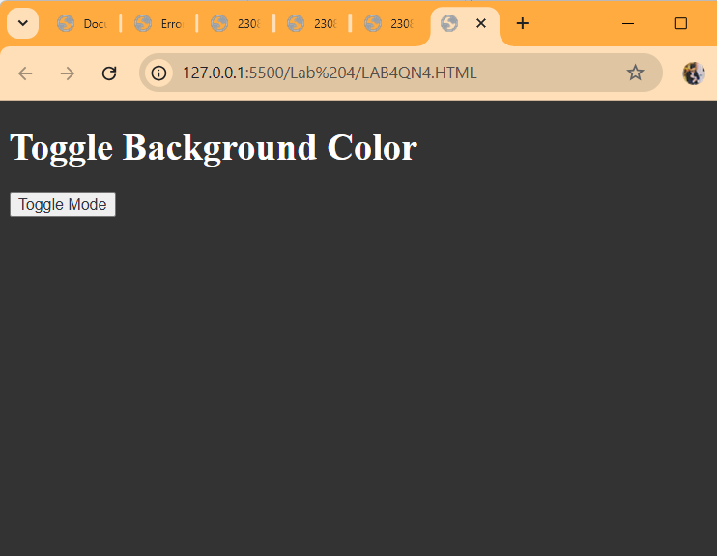
Output:

5. Design a countdown Timer using JavaScript. The timer must count till 5 minutes and
alert the user of time up.
Source Code:
<!DOCTYPE html>
<html lang="en">
<head>
<meta charset="UTF-8" />
<meta name="viewport" content="width=device-width, initial-scale=1.0" />
<title>23081002 Countdown Timer</title>
<style>
body {
font-family: Arial, sans-serif;
text-align: center;
margin-top: 50px;
}
#timer {
font-size: 2em;
margin: 20px;
}
button {
padding: 10px 20px;
font-size: 1em;
cursor: pointer;
}
</style>
</head>
<body>
<h1>Countdown Timer</h1>
<div id="timer">05:00</div>
<button onclick="startTimer()">Start Timer</button>
<script>
let timeLeft = 300;
let timerInterval;
function startTimer() {
if (timerInterval) return;
timerInterval = setInterval(() => {
let minutes = Math.floor(timeLeft / 60);
let seconds = timeLeft % 60;
seconds = seconds < 10 ? "0" + seconds : seconds;
document.getElementById(
"timer"
).innerText = `${minutes}:${seconds}`;
if (timeLeft === 0) {
clearInterval(timerInterval);
alert("Time's up!");
}
timeLeft--;
}, 1000);
}
</script>
</body>
</html>
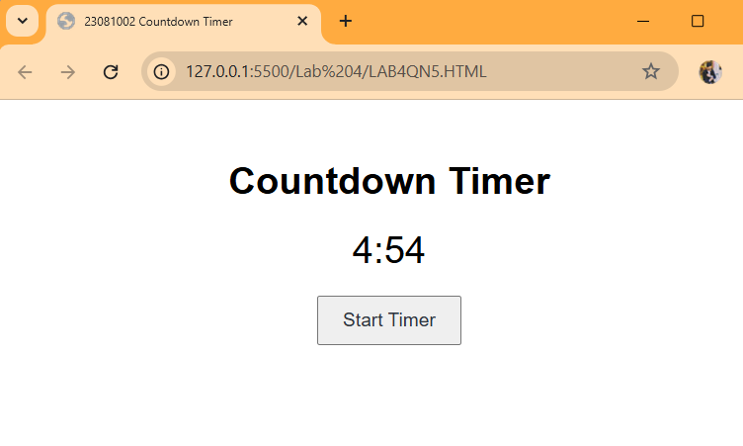
Output:

6. Design a HTML file with 4 divs. Each div should vanish on clicking, Use jQuery.

Source Code:
<!DOCTYPE html>
<html lang="en">
<head>
<meta charset="UTF-8">
<title>Div Disappear on Click</title>
<script src="https://code.jquery.com/jquery-3.6.0.min.js"></script>
<style>
.box {
width: 150px;
height: 150px;
margin: 20px;
display: inline-block;
color: white;
font-size: 18px;
text-align: center;
line-height: 150px;
cursor: pointer;
border-radius: 10px;
}
#div1 { background-color: #e74c3c; }
#div2 { background-color: #3498db; }
#div3 { background-color: #2ecc71; }
#div4 { background-color: #f1c40f; color: black; }
</style>
</head>
<body>

<h2>Click on any box to make it disappear 👇</h2>

<div id="div1" class="box">Div 1</div>
<div id="div2" class="box">Div 2</div>
<div id="div3" class="box">Div 3</div>
<div id="div4" class="box">Div 4</div>

<script>
$(document).ready(function(){
$(".box").click(function(){
$(this).fadeOut();
});
});
</script>
</body>
</html>

Output:
